1. REPORT ON

**INTELLIGENT HUMIDISTAT**

BY

|  |  |
| --- | --- |
| **Meet Kanani** | **2017A7PS0128P** |
| **Aditya Ramaswamy** | **2017A7PS0130P** |
| **Mukkamala Venkat Sai Ram** | **2017A7PS0133P** |
| **S Hariharan** | **2017A7PS0134P** |

Prepared in partial fulfilment of the requirements of the course “Microprocessors and Interfacing” - Course Number: CS F241

AT

**BIRLA INSTITUTE OF TECHNOLOGY & SCIENCE, PILANI**



**BIRLA INSTITUTE OF TECHNOLOGY & SCIENCE, PILANI**

**PILANI – 333031 (RAJASTHAN)**

**Submission Date and Place:** 25thApril 2019, Pilani

|  |  |
| --- | --- |
| **Title of the Project**: Intelligent Humidistat |  |
| **Project Number:** 23  **Group Number:** 91 |  |

**Name of Experts**: Dr. Nitin Chaturvedi

**Designation**: Instructor-in-Charge (ICs)

**Key Words**: Microprocessors, Interfacing, Peripherals like ADC, RAM, OctalBuffers, Latches, LCD Display, Decoders, etc.

**Project Areas**: Microprocessors and Interfacing, Assembly Language Programming

**Abstract**: This project aims to make an Intelligent Humidistat device. As per theproblem statement, we design and emulate the hardware and block diagram of this device in a software called “Proteus”. Various external components are to be used like sensors, potentiometers, RAMs, ROMs, decoders, etc. Using this hardware design and block diagram, we prepare a flowchart on how the system will work when programmed. Following that chart, we thereby write a program in Assembly Language for the device using MASM 611.

|  |  |  |  |
| --- | --- | --- | --- |
|  |  | **TABLE OF CONTENTS** | |
| 1. | Problem Statement | 1 | |
| 2. | Assumptions | 1 | |
| 3. | System Description | 1 | |
| 4. | List of Components | 2 | |
| 5. | Memory Organization | 3 | |
| 6. | I/O Organization | 3 | |
| 7. | Software Flowchart | 5 | |
| 8. | Appendix |  | |
|  | a. ASM Code |  | 6 |
|  | b. Circuit Diagram |  | 23 |
|  | c. References |  | 24 |

**PROBLEM STATEMENT**

**P23: System to be designed: An Intelligent Humidistat**

System Description: A humidistat is supposed to be reset according to the outside temperature – as the outside temperature falls, the humidity level inside the house should be set lower. The purpose of this project is to develop a humidistat which senses the outside temperature and adjusts the humidity accordingly. Two sensors are required: outside temperature and inside humidity. Output is provided via a simple relay with the humidifier (presumably on the furnace) being on or off. Also, readings from the humidity and temperature sensors must be displayed on an LCD display. The entire system can be turned on or off using a single switch.

**ASSUMPTIONS**

The following are the assumptions made regarding the system:

* The outside temperature is between -50° C and 49° C.
* The humidifier turns on when the LED glows, and consequently, the humidifier turns off when the LED stops glowing.
* There is a linear relationship between temperature and humidity, i.e., for an increase in temperature by 1° C, there is an increase in relative humidity by 1% and at 0° C the humidity is 50%. For example – if the temperature is 17° C then the corresponding humidity should be 67% RH.

**SYSTEM DESCRIPTION**

The humidistat is supposed to change the humidity level inside a room according to the outside temperature. When the temperature goes low from the reference temperature (previously measured temperature), the humidifier is turned on through a solid-state relay. Then the humidity level is lowered by the humidifier and the humidity level is monitored until the humidity reaches a value corresponding to the current temperature. The humidifier is then turned off. And then the current temperature is made the reference value and the whole process is repeated again. The sensors are mounted outside the room and are open to the atmosphere. The humidity sensors are mounted inside the room. The humidity sensor measures the humidity in % Relative Humidity. The sensors give analog output. These outputs are converted to digital form through A/D converters. In the memory, there is a look up table which stores the % RH values obtained from the linear relationship for the corresponding temperatures in the temperature range.

**LIST OF COMPONENTS USED**

|  |  |  |  |
| --- | --- | --- | --- |
| Chip No. | Qty. | Chip | Purpose |
| 8086 | 1 | Microprocessor | Central Processing Unit |
| 6116 | 2 | SRAM | Used to store the temporary data (like |
|  |  |  | temperature values, stack, etc.) |
|  |  |  |  |
| 2732 | 2 | EPROM | Erasable Programmable Read Only |
|  |  |  | Memory; in which the code resides |
|  |  |  |  |
| 74138 | 2 | 3:8 Decoder | To Select PPI (8255), and for memory |
|  |  |  | interfacing |
|  |  |  |  |
| 8255 | 2 | Programmable | Provides I/O ports for the other devices |
|  |  | Peripheral Interface |  |
|  |  |  |  |
| ADC0808 | 1 | Analog to Digital | Converts the analog voltage to its digital |
|  |  | Converter | equivalent |
| 74LS245 | 2 | 8-bit bidirectional | Buffering Data bus |
|  |  | buffer |  |
|  |  |  |  |
| LM016L | 1 | 16x2 alphanumeric LCD | Displays the current temperature and humidity |
|  |  |  |  |
| 74LS373 | 3 | 8-bit octal latches | Latching the address bus |
|  |  |  |  |
|  |  |  |  |

**OTHER HARDWARE USED**

1. Logic Gates – These are primarily used for building decoding logic for memory interfacing and I/O interfacing.
2. Tri-state buffer – It is used to generate interrupt vector numbers.
3. Solid-State Relay – It is used as a switch to power on high voltage devices.
4. LED – It is used to signal the activity of the humidifier.
5. Potentiometers – They are used to simulate input from sensors.
6. Switches – They are used to power off/on the system and the LCD.

**MEMORY ORGANIZATION**

Memory is divided into odd and even banks for word and byte transfer.

**ROM:**

ROM1 EVEN: 00000h – 01FFEh

ROM1 ODD: 00001h - 01FFFh

**RAM:**

RAM1 EVEN: 02000h – 02FFEh

RAM1 ODD: 02001h -- 02FFFh

The data segment starts at the address of 00000h

Code Segment begins at 00000h.

**MEMORY AND ADDRESS MAP**

|  |  |  |  |  |  |  |  |  |  |  |  |  |  |  |  |  |  |  |  |  |
| --- | --- | --- | --- | --- | --- | --- | --- | --- | --- | --- | --- | --- | --- | --- | --- | --- | --- | --- | --- | --- |
| CHIP | **A19 A18 A17 A16** | | | | **A15 A14 A13 A12** | | | | **A11 A10 A9 A8 A7 A6 A5 A4** | | | | | | | | **A3 A2 A1A0** | | | |
| EPROM |  |  |  |  |  |  |  |  |  |  |  |  |  |  |  |  |  |  |  |  |
| 2732 |  |  |  |  |  |  |  |  |  |  |  |  |  |  |  |  |  |  |  |  |
| From |  |  |  |  |  |  |  |  |  |  |  |  |  |  |  |  |  |  |  |  |
| 00000h | 0 | 0 | 0 | 0 | 0 | 0 | 0 | 0 | 0 | 0 | 0 | 0 | 0 | 0 | 0 | 0 | 0 | 0 | 0 | 0 |
| To |  |  |  |  |  |  |  |  |  |  |  |  |  |  |  |  |  |  |  |  |
| 01FFFh | 0 | 0 | 0 | 0 | 0 | 0 | 0 | 1 | 1 | 1 | 1 | 1 | 1 1 | | 1 1 | | 1 | 1 | 1 | 1 |
| SRAM |  |  |  |  |  |  |  |  |  |  |  |  |  |  |  |  |  |  |  |  |
| 6116 |  |  |  |  |  |  |  |  |  |  |  |  |  |  |  |  |  |  |  |  |
| From |  |  |  |  |  |  |  |  |  |  |  |  |  |  |  |  |  |  |  |  |
| 02000H | 0 | 0 | 0 | 0 | 0 | 0 | 1 | 0 | 0 | 0 | 0 | 0 | 0 0 | | 0 0 | | 0 | 0 | 0 | 0 |
| To |  |  |  |  |  |  |  |  |  |  |  |  |  |  |  |  |  |  |  |  |
| 02FFFh | 0 | 0 | 0 | 0 | 0 | 0 | 1 | 0 | 1 | 1 | 1 | 1 | 1 1 | | 1 1 | | 1 | 1 | 1 | 1 |

**I/O INTERFACING**

The input and output devices of the system are connected to the processor using 8255 Programmable Peripheral Interfacing controllers. Here we connect the A0 and A1 of the 8255 to the A1 and A2 of the 8086’s address bus respectively and also we connected the of 8255 to the output of decoder 74139 for selecting the chip. Addresses for the chips are as follow (All have been given even address space):

I/O Mapping

|  |  |
| --- | --- |
| Address of 8255-1 port-A | : 00h |
| Address of 8255-1 port-B | : 02h |
| Address of 8255-1 port-C | : 04h |
| Address of 8255-1 control register | : 06h |
| Address of 8255-2 port-A | : 08h |
| Address of 8255-2 port-B | : 0Ah |
| Address of 8255-2 port-C | : 0Ch |
| Address of 8255-2 control register | : 0Eh |

**PORT ADDRESS MAPS**

|  |  |  |  |  |  |  |  |  |  |  |  |  |  |  |  |  |  |  |  |  |
| --- | --- | --- | --- | --- | --- | --- | --- | --- | --- | --- | --- | --- | --- | --- | --- | --- | --- | --- | --- | --- |
| CHIP | **A19 A18 A17 A16** | | | | **A15 A14 A13 A12** | | | | **A11 A10 A9 A8 A7 A6 A5 A4** | | | | | | | | **A3 A2 A1A0** | | | |
| 8255 - 1 |  |  |  |  |  |  |  |  |  |  |  |  |  |  |  |  |  |  |  |  |
|  |  |  |  |  |  |  |  |  |  |  |  |  |  |  |  |  |  |  |  |  |
| From |  |  |  |  |  |  |  |  |  |  |  |  |  |  |  |  |  |  |  |  |
| 00000h | 0 | 0 | 0 | 0 | 0 | 0 | 0 | 0 | 0 | 0 | 0 | 0 | 0 | 0 | 0 | 0 | 0 | 0 | 0 | 0 |
| To |  |  |  |  |  |  |  |  |  |  |  |  |  |  |  |  |  |  |  |  |
| 00006h | 0 | 0 | 0 | 0 | 0 | 0 | 0 | 0 | 0 | 0 | 0 | 0 | 0 0 | | 0 0 | | 0 | 1 | 1 | 0 |
| 8255 - 2 |  |  |  |  |  |  |  |  |  |  |  |  |  |  |  |  |  |  |  |  |
|  |  |  |  |  |  |  |  |  |  |  |  |  |  |  |  |  |  |  |  |  |
| From |  |  |  |  |  |  |  |  |  |  |  |  |  |  |  |  |  |  |  |  |
| 00008H | 0 | 0 | 0 | 0 | 0 | 0 | 0 | 0 | 0 | 0 | 0 | 0 | 0 0 | | 0 0 | | 1 | 0 | 0 | 0 |
| To |  |  |  |  |  |  |  |  |  |  |  |  |  |  |  |  |  |  |  |  |
| 0000Eh | 0 | 0 | 0 | 0 | 0 | 0 | 0 | 0 | 0 | 0 | 0 | 0 | 0 0 | | 0 0 | | 1 | 1 | 1 | 0 |

**SOFTWARE FLOWCHART**

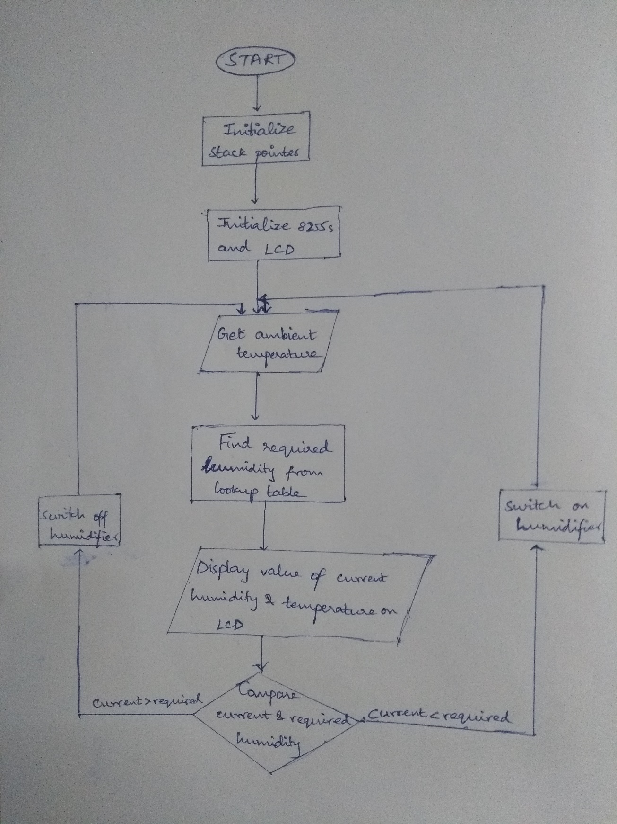

**APPENDIX**

1. **ASSEMBLY CODE**

#make_bin#

#LOAD_SEGMENT=FFFFh#

#LOAD_OFFSET=0000h#

#CS=0000h#

#IP=0000h#

#DS=0000h#

#ES=0000h#

#SS=0000h#

#SP=FFFEh#

#AX=0000h#

#BX=0000h#

#CX=0000h#

#DX=0000h#

#SI=0000h#

#DI=0000h#

#BP=0000h#

temp_ref db 0,1,2,3,4,5,6,7,8,9,10,11,12,13,14,15,16,17,18,19,20,21,21,23,24,25,26,27,28,29,30,31,32,33,34,35,36,37,38,39,40,41,42,43,44,45,46,47,48,49,50,51,52,53,54,55,56,57,58,59,60,61,62,63,64,65,66,67,68,69,70,71,72,73,74,75,76,77,78,79,80,81,82,83,84,85,86,87,87,89,90,91,92,93,94,95,96,97,98,99,100

ADC_out db 00h,02h,05h,08h,0ah,0dh,0fh,12h,14h,17h,1ah,1ch,1fh,21h,24h,26h,29h,2bh,2eh,30h,33h,36h,38h,3bh,3dh,40h,42h,45h,47h,4ah,4dh,4fh,52h,54h,57h,59h,5ch,5eh,61h,63h,66h,69h,6bh,6eh,70h,73h,75h,78h,7ah,7dh,7fh,82h,85h,87h,8ah,8ch,8fh,91h,94h,96h,99h,9ch,9eh,0a1h,0a3h,0a6h,0a8h,0abh,0adh,0b0h,0b2h,0b5h,0b8h,0bah,0bdh,0bfh,0c2h,0c4h,0c7h,0c9h,0cch,0cfh,0d1h,0d4h,0d6h,0d9h,0dbh,0deh,0e0h,0e3h,0e5h,0e8h,0ebh,0edh,0f0h,0f2h,0f5h,0f7h,0fah,0fch,0ffh

temp_t db ? ;current temperature

temp_h db ? ;current humidity

cmp_t db ? ;voltage for current temperature

neg_flag db 00h ;check sign of temperature

origin db 50 ;voltage for 0 degree temperature

jmp strt

db 1024 dup(0)

strt: cli

;intialize ds, es,ss to start of RAM

mov ax,0000h

mov ds,ax

mov es,ax

mov ss,ax

mov sp,0FFFEH

; initializing 8255

sti

mov al,88h ; control word for 8255(for LCD)

out 06h,al

mov al,89h ; control word for 8255(for ADC)

out 0Eh,al

mov al,00h ;default low output for PC0

out 0ch,al

;initializing LCD

call dly_minor

mov al,04h

out 02h,al

call dly_minor

mov al,04h ; to make rs=0 and r/w=0

out 02h,al

mov al,38h ;function set

out 00h,al

mov al,04h

out 02h,al

call dly_minor

mov al,00h ;to make rs=0 and r/w=0

out 02h,al

call dly_minor

mov al,0Ch ; display on

out 00h,al

mov al,04h

out 02h,al

call dly_minor

mov al,00h

out 02h,al

mov al,06h ; set entry mode

out 00h,al

call dly_minor

mov al,04h

out 02h,al

call dly_minor

mov al,00h

out 02h,al

mov al,4ch

out 00h,al

call dly_minor

start: call idle

call clear_LCD

call hello_world

call dly_std

seq: call getHmd

call getTemp

call clear_LCD

call dly_std

call display_lcd

mov al,cmp_t

mov bl,temp_h

cmp al,bl

ja inc_hum

jb dec_hum

call idle

jmp repeat

inc_hum: call inc_hmd

jmp repeat

dec_hum: call dec_hmd

jmp repeat

repeat: call dly_major

jmp seq

dly_minor proc near

mov cl,30

aa:

dec cl

jnz aa

ret

dly_minor endp

dly_major proc near

mov cx,0ffffh

bb:

dec cx

jnz bb

ret

dly_major endp

dly_std proc near

mov cx,5555h

st:

dec cx

jnz st

ret

dly_std endp

getTemp PROC NEAR ;get temperature through ADC

mov al,00h

out 0eh,al ; PC0=0

call dly_major

mov al,82h

out 0eh,al

in AL,0AH

lea si,ADC_out

lea di,temp_ref

dec si

cc: inc si

cmp al,[si]

jnz cc

sub si,offset ADC_out

add di,si

mov al,[di]

mov cmp_t,al

cmp [di],50

jge pos

mov neg_flag,01h ;for negative temperature

mov al,[di]

mov origin,50

sub origin,al

mov al,origin

mov temp_t,al

jmp con

pos: mov neg_flag,00h ;for positive temperature

mov al,[di]

sub al,50

mov temp_t,al

con: call CONVBCD

ret

getTemp ENDP

getHmd PROC NEAR ;get humidity through ADC

mov al,01h

out 0eh,al ; PC0=1

call dly_major

mov al,82h

out 0eh,al

in al,0aH

lea si,ADC_out

lea di,temp_ref

dec si

dd: inc si

mov bl,[si]

cmp al,bl

jnz dd

sub si,offset ADC_out

add di,si

mov al,[di]

mov temp_h,al

call CONVBCD

mov dx,bx

ret

getHmd ENDP

;increase humidity

inc_hmd proc near

mov al,0eh

out 0eh,al ;reset decrease humidity signal

mov al,0dh

out 0eh,al ;set increase humidity signal

ret

inc_hmd endp

;decrease humidity

dec_hmd proc near

mov al,0ch

out 0eh,al ;reset increase humidity signal

mov al,0fh

out 0eh,al ;set decrease humidity signal

ret

dec_hmd endp

;idle humidifier when temperature and humidity are equal

idle proc near

mov al,0eh

out 0eh,al

mov al,0ch

out 0eh,al

ret

idle endp

clear_LCD proc near

mov al,00h

out 02h,al

call dly_minor

mov al,01h ;Clear LCD display

out 00h,al

call dly_minor

mov al,04h

out 02h,al

call dly_minor

mov al,00h

out 02h,al

RET

clear_LCD endp

hello_world proc near

mov al,0A0h

out 00h,al

call dly_minor

mov al,05h

out 02h,al

call dly_minor

mov al,01h

out 02h,al ;prints Space

mov al,0A0h

out 00h,al

call dly_minor

mov al,05h

out 02h,al

call dly_minor

mov al,01h

out 02h,al ;prints Space

mov al,0A0h

out 00h,al

call dly_minor

mov al,05h

out 02h,al

call dly_minor

mov al,01h

out 02h,al ;prints Space

mov al,48h

out 00h,al

call dly_minor

mov al,05h

out 02h,al

call dly_minor

mov al,01h

out 02h,al ;prints H

mov al,65h

out 00h,al

call dly_minor

mov al,05h

out 02h,al

call dly_minor

mov al,01h

out 02h,al ;prints e

mov al,6ch

out 00h,al

call dly_minor

mov al,05h

out 02h,al

call dly_minor

mov al,01h

out 02h,al ;prints l

mov al,6ch

out 00h,al

call dly_minor

mov al,05h

out 02h,al

call dly_minor

mov al,01h

out 02h,al ;prints l

mov al,6fh

out 00h,al

call dly_minor

mov al,05h

out 02h,al

call dly_minor

mov al,01h

out 02h,al ;prints o

mov al,0A0h

out 00h,al

call dly_minor

mov al,05h

out 02h,al

call dly_minor

mov al,01h

out 02h,al ;prints Space

mov al,57h

out 00h,al

call dly_minor

mov al,05h

out 02h,al

call dly_minor

mov al,01h

out 02h,al ;prints W

mov al,6fh

out 00h,al

call dly_minor

mov al,05h

out 02h,al

call dly_minor

mov al,01h

out 02h,al ;prints o

mov al,72h

out 00h,al

call dly_minor

mov al,05h

out 02h,al

call dly_minor

mov al,01h

out 02h,al ;prints r

mov al,6ch

out 00h,al

call dly_minor

mov al,05h

out 02h,al

call dly_minor

mov al,01h

out 02h,al ;prints l

mov al,64h

out 00h,al

call dly_minor

mov al,05h

out 02h,al

call dly_minor

mov al,01h

out 02h,al ;prints d

ret

hello_world endp

display_lcd PROC NEAR ;Display temperature and humidity on LCD

mov al,54h

out 00h,al

call dly_minor

mov al,05h

out 02h,al

call dly_minor

mov al,01h

out 02h,al ;prints 'T'

mov al,65h

out 00h,al

call dly_minor

mov al,05h

out 02h,al

call dly_minor

mov al,01h

out 02h,al ;prints 'e'

mov al,6dh

out 00h,al

call dly_minor

mov al,05h

out 02h,al

call dly_minor

mov al,01h

out 02h,al ;prints 'm'

mov al,70h

out 00h,al

call dly_minor

mov al,05h

out 02h,al

call dly_minor

mov al,01h

out 02h,al ;prints 'p'

mov al,65h

out 00h,al

call dly_minor

mov al,05h

out 02h,al

call dly_minor

mov al,01h

out 02h,al ;prints 'e'

mov al,72h

out 00h,al

call dly_minor

mov al,05h

out 02h,al

call dly_minor

mov al,01h

out 02h,al ;prints 'r'

mov al,61h

out 00h,al

call dly_minor

mov al,05h

out 02h,al

call dly_minor

mov al,01h

out 02h,al ;prints 'a'

mov al,74h

out 00h,al

call dly_minor

mov al,05h

out 02h,al

call dly_minor

mov al,01h

out 02h,al ;prints 't'

mov al,75h

out 00h,al

call dly_minor

mov al,05h

out 02h,al

call dly_minor

mov al,01h

out 02h,al ;prints 'u'

mov al,72h

out 00h,al

call dly_minor

mov al,05h

out 02h,al

call dly_minor

mov al,01h

out 02h,al ;prints 'r'

mov al,65h

out 00h,al

call dly_minor

mov al,05h

out 02h,al

call dly_minor

mov al,01h

out 02h,al ;prints 'e'

mov al,0A0h

out 00h,al

call dly_minor

mov al,05h

out 02h,al

call dly_minor

mov al,01h

out 02h,al ;prints Space

cmp neg_flag,00h

jz hh

mov al,2dh

out 00h,al

call dly_minor

mov al,05h

out 02h,al

call dly_minor

mov al,01h

out 02h,al ;prints '-'

jmp nn

hh: mov al,0A0h

out 00h,al

call dly_minor

mov al,05h

out 02h,al

call dly_minor

mov al,01h

out 02h,al ;prints Space

nn: mov al,bh

out 00h,al

call dly_minor

mov al,05h

out 02h,al

call dly_minor

mov al,01h

out 02h,al ;prints number stored in bh

mov al,bl

out 00h,al

call dly_minor

mov al,05h

out 02h,al

call dly_minor

mov al,01h

out 02h,al ;prints number store in bl

mov al,0DFh

out 00h,al

call dly_minor

mov al,05h

out 02h,al

call dly_minor

mov al,01h

out 02h,al ;prints 'DEG'

mov al,43h

out 00h,al

call dly_minor

mov al,05h

out 02h,al

call dly_minor

mov al,01h

out 02h,al ;prints 'C'

mov al,0A0h

out 00h,al

call dly_minor

mov al,05h

out 02h,al

call dly_minor

mov al,01h

out 02h,al ;prints Space

mov al,0c0h

out 00h,al

mov al,04h

out 02h,al

call dly_minor

mov al,00h

out 02h,al

call dly_minor

mov al,48h

out 00h,al

call dly_minor

mov al,05h

out 02h,al

call dly_minor

mov al,01h

out 02h,al ;prints 'H'

mov al,75h

out 00h,al

call dly_minor

mov al,05h

out 02h,al

call dly_minor

mov al,01h

out 02h,al ;prints 'u'

mov al,6dh

out 00h,al

call dly_minor

mov al,05h

out 02h,al

call dly_minor

mov al,01h

out 02h,al ;prints 'm'

mov al,69h

out 00h,al

call dly_minor

mov al,05h

out 02h,al

call dly_minor

mov al,01h

out 02h,al ;prints 'i'

mov al,64h

out 00h,al

call dly_minor

mov al,05h

out 02h,al

call dly_minor

mov al,01h

out 02h,al ;prints 'd'

mov al,69h

out 00h,al

call dly_minor

mov al,05h

out 02h,al

call dly_minor

mov al,01h

out 02h,al ;prints 'i'

mov al,74h

out 00h,al

call dly_minor

mov al,05h

out 02h,al

call dly_minor

mov al,01h

out 02h,al ;prints 't'

mov al,79h

out 00h,al

call dly_minor

mov al,05h

out 02h,al

call dly_minor

mov al,01h

out 02h,al ;prints 'y'

mov al,0A0h

out 00h,al

call dly_minor

mov al,05h

out 02h,al

call dly_minor

mov al,01h

out 02h,al ;prints Space

mov al,0A0h

out 00h,al

call dly_minor

mov al,05h

out 02h,al

call dly_minor

mov al,01h

out 02h,al ;prints Space

mov al,0A0h

out 00h,al

call dly_minor

mov al,05h

out 02h,al

call dly_minor

mov al,01h

out 02h,al ;prints Space

mov al,0A0h

out 00h,al

call dly_minor

mov al,05h

out 02h,al

call dly_minor

mov al,01h

out 02h,al ;prints Space

mov al,0A0h

out 00h,al

call dly_minor

mov al,05h

out 02h,al

call dly_minor

mov al,01h

out 02h,al ;prints Space

mov al,dh

out 00h,al

call dly_minor

mov al,05h

out 02h,al

call dly_minor

mov al,01h

out 02h,al ;prints character in dh

mov al,dl

out 00h,al

call dly_minor

mov al,05h

out 02h,al

call dly_minor

mov al,01h

out 02h,al ;prints character in dl

mov al,25h

out 00h,al

call dly_minor

mov al,05h

out 02h,al

call dly_minor

mov al,01h

out 02h,al ;prints '%'

ret

display_lcd endp

CONVBCD PROC NEAR ;convert binary to bcd

mov bh,0ffH

BACK1: INC BH

SUB AL,0AH

JNC BACK1

ADD AL,0AH

MOV BL,30H

ADD BH,BL

ADD BL,AL

RET

CONVBCD ENDP

1. **CIRCUIT DIAGRAM**

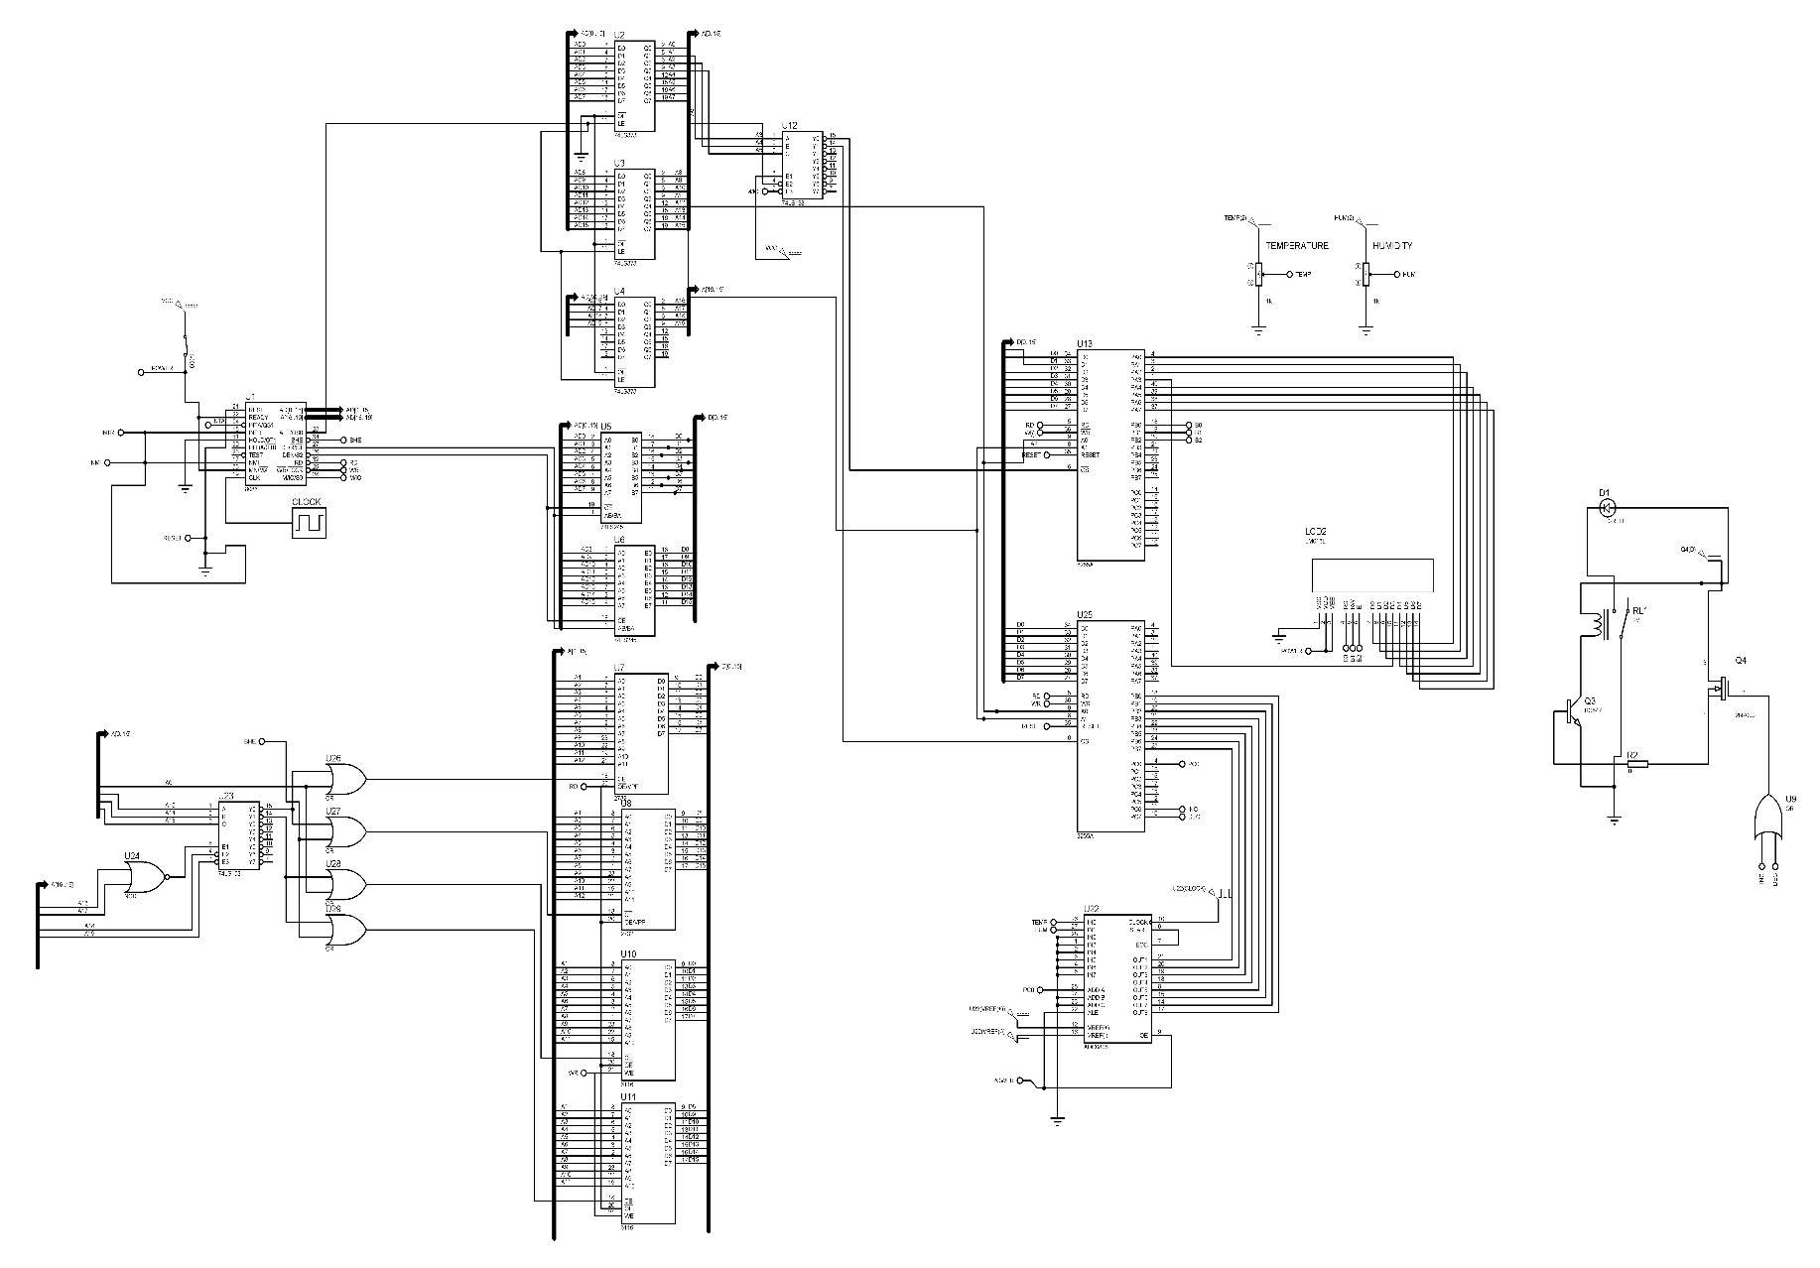

1. **REFERENCES**

A 16x2 LCD was used. The following were used to understand its working.

1. <https://panda-bg.com/datasheet/2134-091834-LCD-module-TC1602D-02WA0-16x2-STN.pdf>
2. <https://www.csus.edu/indiv/p/pangj/class/lcd/instruct.html>